IELTS WRITING

Task 1: 1/3 score, 20 mins, 150 words,

Task 2: 2/3 score , 40 mins, 250 words,

四项评分标准

TR：(task response)/TA(task achievement ) ： 25%

CC:(coherence& cohesion) ： 25%

LR：lexical resource ：25%

GRA:grammatical range & accuracy ： 25%

Underlength

Penalty

Illegible

Off-topic

Memorized

TASK 1

类型：

* 数据类图表：line graph, bar chart,pie chart, table

静态图：二对多；多对多

动态图： 线图；非线图动态图（两个时间点； 三个及以上时间点）

* 非数据类图表 1：flow chart（工业制造；自然现象；生命特征）
* 非数据类图表2：map （变迁题；选址题；纯地点描述）

Task 1篇章结构

* **Deductive analysis(演绎)**

1. 开头段：改写题目

2. 宏观概括

3. 微观对比分析 （划分若干个段落）

* **Inductive analysis (归纳)**

1. 开头段：改写题目

2. 微观对比分析（划分若干个段落）

3. 宏观概括

**开头段：改写题目**

1. 话题性词汇

* 词性
* 近义词
* 解释
* 词序&增减词

2. 非话题性词汇

* 图表类型

Graph-line graph

Chart- bar chart; pie chart

Table-table

Diagram- flow chart; map

* 展示性动词

show=give information on=illustrate

* 数据类图表

百分比the percentage/proportion(of)

数量amount(U)& quantity(C&U)，number(C)

统称figure(s); data

* 状语

地点状语

时间状语（时间点&时间区间）

3. 增补内容

Example 1:

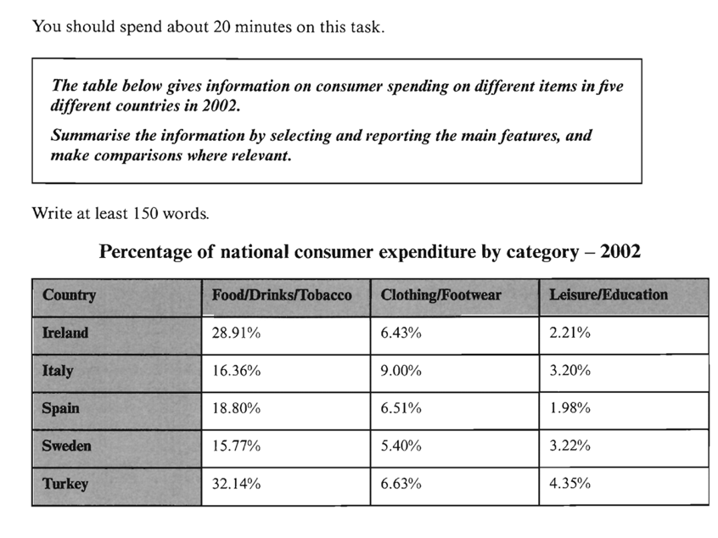

The table illustrates **the proportion of national consumer expenditure on** food/drinks/tobacco, clothing/footwear and leisure/education in five countries in the year of 2002.

Example 2:

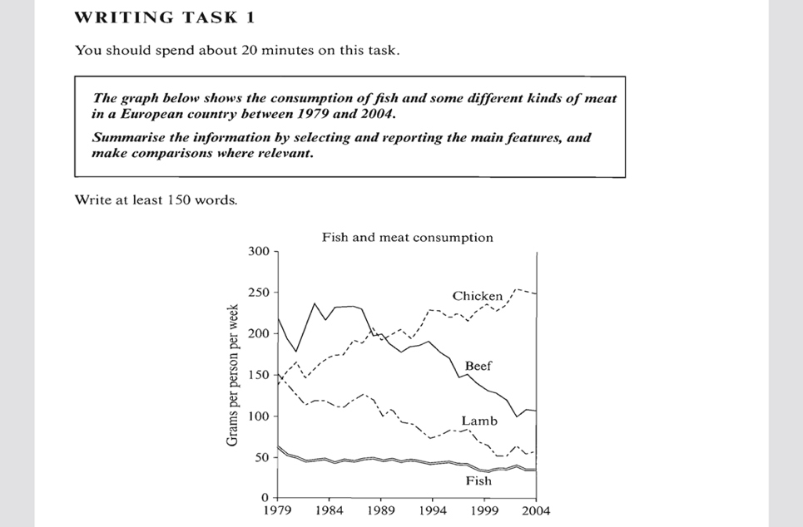

The line graph illustrates **the amounts of fish, chicken, beef and lamb eaten** by a European country over the 1979-2004 period, and units are measured in grams per capita per week.

Practice 1:

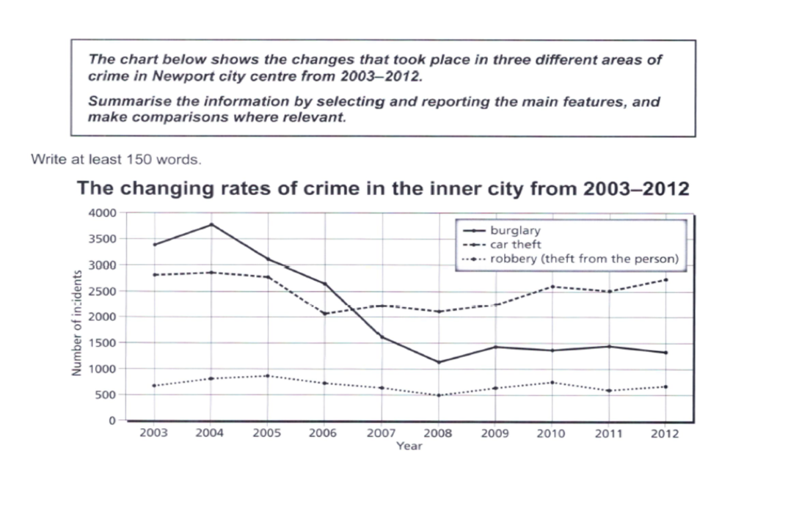

Practice 2:

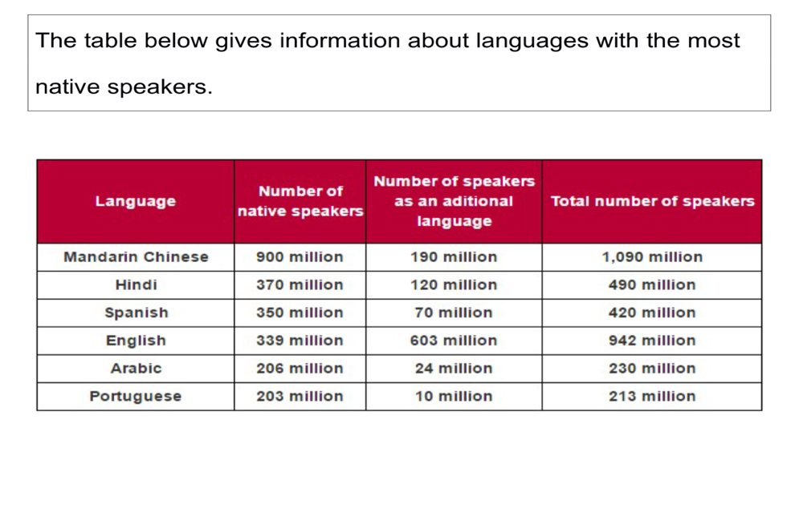

**TASK 1 写作类型1： 静态图表（完全对比图）**

二对多；多对多

考点：大小对比

Task achievement(25%)

1. Summarise:

* **高低多少**
* **差距（明显／不明显）**
* 正比／反比

对象可以归纳

2. Main features: (挑选重要数据意识)& relevant comparison (有效对比)

多对多： 最大值，相似对象（数据&特征）；相反对象

二对多：差距最大，相似对象，相反对象

静态语法考点：大小对比（高低）

Primary school: F>M

A>B：1.比较级&最高级 2.超过动词(outnumber& overtake) 3. 其他

1. There were **more** female teachers in the primary school than male teachers /**More** female teachers were employed in the primary school than male teachers.
2. Females **predominated** in the primary school.
3. Female teachers **outnumbered** male teachers in the primary school.
4. The percentage of female teachers was **higher(more)** than that of male teachers in the primary school.
5. The percentage of female teachers **overtook(超过)** that of male teachers in the primary school.
6. Female teachers **accounted for(made up/represented/constituted占据动词)** a larger percentage in the primary school.

程度词

稍微: slightly/marginally +比较级

远远：significantly/far/much+比较级 ; by far +最高级

**Example 1: 静态图（多对多）**



Overall, all countries **spent most** on food/drinks/tobacco, and **the lowest expenditure** was on leisure/education. **The expenditure in** Turkey **was higher** than the other countries in two out of three.

When it comes to food,drinks, and tobacco, Turkey and Ireland spent **far more** than the rest of countries at 32.14% and 28.91% respectively. Spain, Sweden and Italy **paid** less than 20% **for** this item, with the relatively lower level in Sweden at 15.77%.

However, Italy **spent more** than the other countries on clothing& footwear(9%) as opposed to **the lowest expenditure** which could be seen in Sweden at 5.4%. The remaining three countries spent on average around 6.5%.

**The lowest expenditure** was on leisure& education which accounted for under 5% in all countries. Turkey **spent most** on this category at 4.35% of their **national expenditure**.

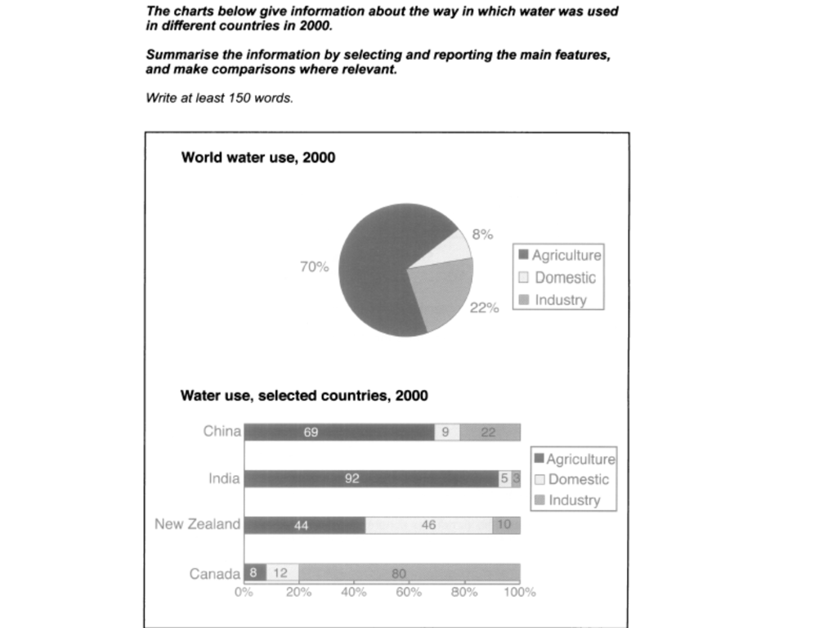

India and China consumed the vast majority of water for the agricultural purpose(92% and 69% respectively) as opposed to New Zealand who used 44% of water in this sector. Surprisingly, the agriculture use was minimal in Canada, accounting for merely 8%.

By contrast, the industrial water use in Canada clearly overtook that in the rest of countries, with up to 80% of water consumed for this purpose....

**Example 2: 静态图（二对多）**

**Test 3, C4**

**Model answer**



The chart gives information about post-school qualifications in terms of the different levels of further education reached by men and women in Australia in 1999.

We can see immediately that there were substantial differences in the proportion of men and women at different levels. The biggest gender difference is at the lowest post-school level, **where** 90% of those who held a skilled vocational diploma were men, compared with only 10% of women. By contrast,**more** women held undergraduate diplomas(70%) and **marginally more** women reached degree level(55%)

At the higher levels of education, men with postgraduate diplomas clearly **outnumbered** their female counterparts (70% and 30%, respectively), and also constituted 60% Master's graduates.

Thus we can see that **more** men than women hold qualifications at the lower and higher levels of education, while(whereas, 前后主语属性一致） **more** women reach undergraduate diploma level than men. The gender difference **is smallest** at the level of Bachelor' s degree.

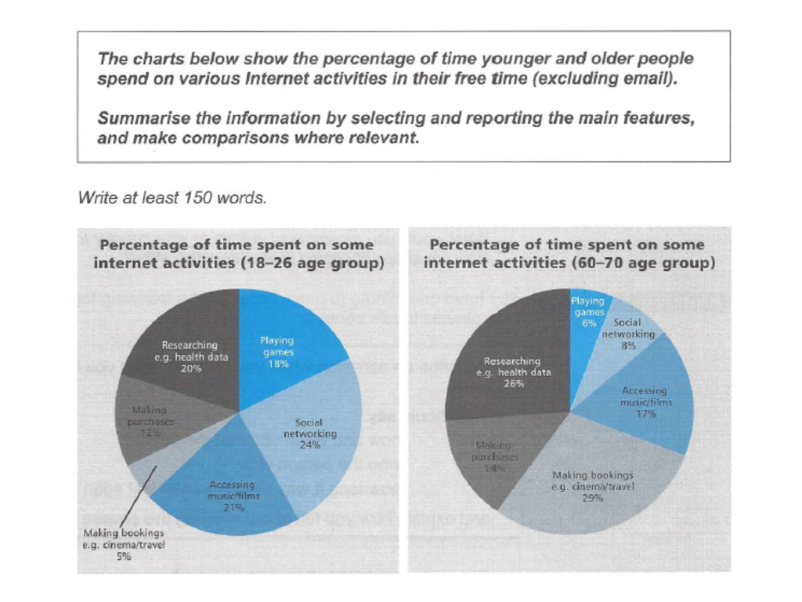

The most noticeable difference(gap) can be found on making bookings, **where** older users spend **far more** leisure time than younger counterparts (29% and 5% respectively). Researching is another popular internet activity for the older group who spend 26% of free time, compared to 20% for the younger group.

差别小

differ slightly(marginally)

Slight (marginal/insignificant) differences(gap)

Nearly as...as

Making online purchase is nearly as popular for older users as for younger users/Older users spend nearly as much leisure time on making bookings as younger users

基本句式

Making bookings: O>Y

1. Older users spend **far more** leisure time on making bookings than younger counterparts.
2. Making bookings is **far more popular** for older users than younger counterparts.
3. Making bookings takes up(时空占据) **much more** leisure time for older users than younger counterparts.
4. The percentage of time spent on making bookings is **much higher** for older users than that for younger users.
5. The percentage of time spent on making bookings for older users **overtakes** that for younger users.

**TASK 1 写作类型2： 动态图表（趋势对比图）**

1. 动态线图

2. 非线图动态图（动态饼图，表格&柱状图）- 两个时间点

3. 非线图动态图（动态饼图，表格&柱状图）-三个及以上时间点

TA (25%)

1. Summarise

* 总体趋势（起点-终点）
* 总体趋势+重要排名
* 正比／反比

2. Main features

* 时间点：起点，中间点：（交点，骤变点，重要转折点，明显的峰值／谷值），终点
* 非时间点：重要排位& 变化幅度&数值

3. Comparison (similarity& difference)

第一对象：起点最大值或者变化幅度最明显的对象开始

动态分组

* 趋势
* 变化幅度（快-慢）
* 数量（高-低)

**动态趋势表达（5*3）**

1. 上升

* a rise, rise, rose
* an increase, increase, increased
* a growth, grow, grew
* Show an upward trend
* 暴涨：soar(to, verb)/rocket(to, verb)=increase rapidly=a rapid increase

2. 下降

* a decrease, decrease, decreased
* a decline, decline, declined
* a dip, dip, dipped
* Show a downward trend
* 暴跌：slump（n&v);plummet(v), plunge(n&v)=decrease rapidly=a rapid decrease

上升／下降最终值（到）：to

上升／下降了变化幅度（了）； by

A: 20% -40%.

Increase by 20%

Increase to 40%

Increase by 20% to 40%

3. 峰值／谷值（线图)

* a peak(of)=the highest level , peak(at), peaked(at)
* a bottom(of)=the lowest level, bottom out(at), bottomed out(at)

4. 波动

* fluctuation(s), fluctuate (between.... and...), fluctuated
* variation(s), vary (between ... and...), varied

5. 稳定

* remain stable(steady；unchanged) at
* level out(at) /level off(at)

**程度修饰词(2)**

1. 缓慢

Slight(ly), marginal(ly) , gradual(ly), modest(ly)

2. 急剧

rapid(ly); sharp(ly), significant(ly), dramatic(ally)

UK- coffee sales increased(1.5-20)

1. The coffee sales in the UK increased enormously, from 1.5-20 million euros//The coffee sales in the UK increased enormously, from 1.5 million euros in 1999 to 20 million euros in 2004.
2. There was an enormous increase in the coffee sales in the UK, from 1.5-20 million euros.
3. The coffee sales in the UK showed an upward trend, **starting at** 1.5 million euros and **ending at** 20 million euros.
4. The coffee sales saw an enormous increase，from 1.5-20 million euros.

Example 1: line graph

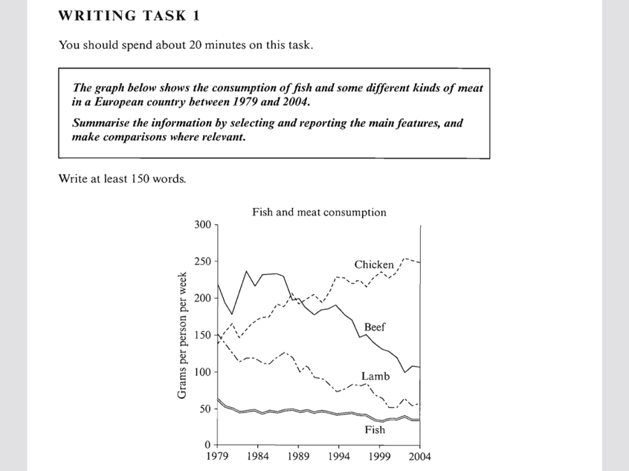

动态主语

1. the consumption of beef
2. The beef consumption
3. The amount of consumed beef=the amount of beef consumed by
4. The amount of eaten beef=the amount of beef eaten by
5. The popularity of beef

The graph illustrates changes **in the amounts of beef, lamb, chicken and fish consumed** in a particular European country between 1979 and 2004.

In 1979 beef was by far **the most popular** of these foods, with about 225 grams consumed per person per week. Lamb and chicken were eaten in similar quantities(around 150 grams), while much less fish **was consumed** (just over 50 grams).

However, during this 25-year period **the consumption of beef and lamb** fell dramatically to approximately(about/around/roughly) 100 grams and 55 grams respectively. **The consumption of fish** also declined, but much less significantly to just below 50 grams, so although it remained the least popular food, **consumption levels** were the most stable.

**The consumption of chicken**, on the other hand, showed an upward trend, overtaking **that of lamb** in 1980 and **that of beef** in 1989. By 2004 it had soared to almost 250 grams per person per week. ·

Overall, the graph shows how **the consumption of chicken** increased dramatically while **the popularity of these other foods** decreased over the period.

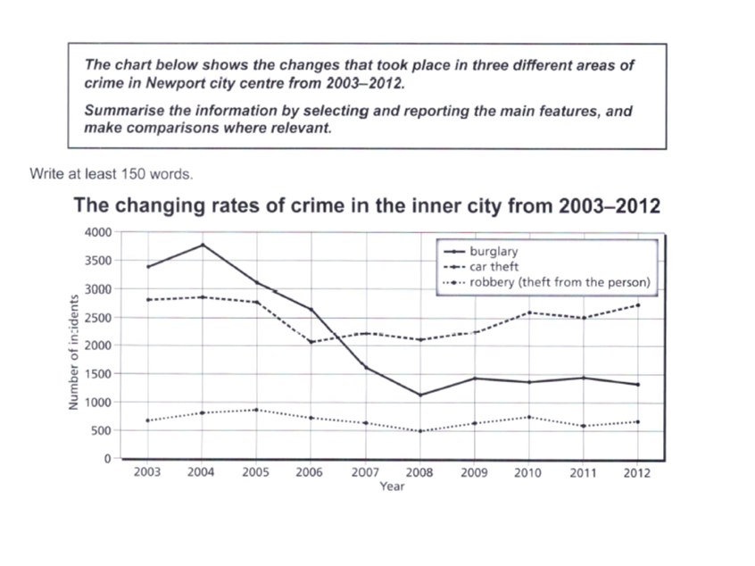

动态主语

1. The changing rate of burglary
2. The burglary rate
3. The number of committed burglary

P2: The line graph shows the changing rate of burglary **decreasing** dramatically over the nine-year period: In 2003, burglary was by far the most common criminal act, with just below 3500 cases reported in this city centre. **After** an initial increase, this rate reached a peak in 2004 **when** it hit 3750. **From then on,** there was a sharp decrease **until** 2008. **At this point** the figure stood at just over 1,000 incidents. This rose slightly in 2009, and **then** continued to fluctuate **for the remaining period.**

P3: In 2003, the number of cars stolen was around 2,800 and followed a similar trend to burglary **until** 2006. At this point this rate rose and overtook that of burglary, **standing at** around 2,200 in 2007. There was a marginal decrease **in the following years,** **but after that**, the trend was generally onwards.

P4: Finally, robbery was always been a minor problem for Newport. The number of committed robbery fluctuated between 500 to 1000.

Example 2: 两个时间点

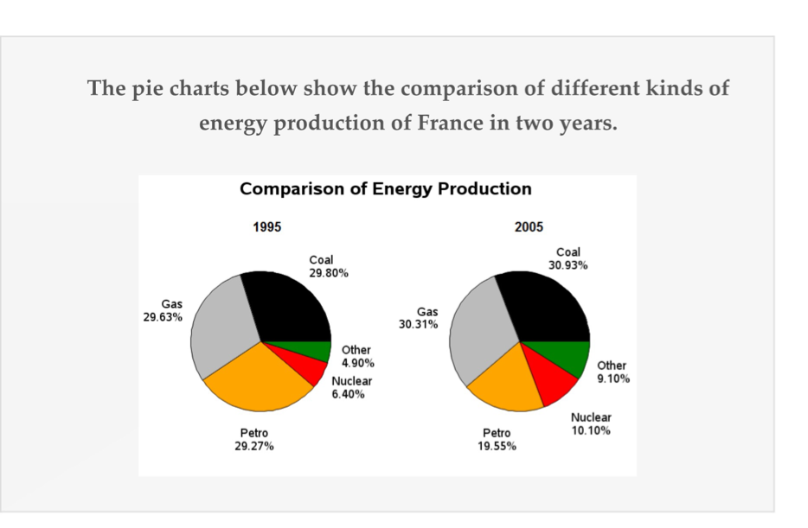

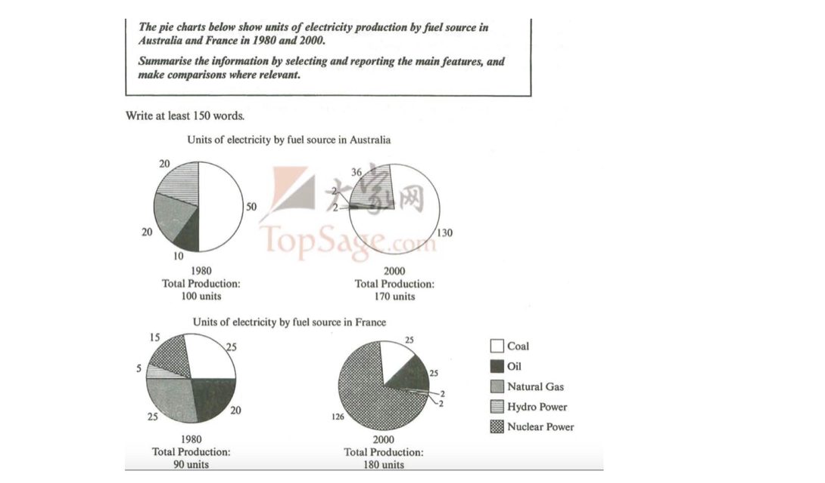

动态主语

1. The electricity production by coal
2. The amount of electricity produced by coal
3. The electricity generation by coal
4. The amount of electricity generated(created) by coal

写法1: **The total electricity production** by different fuel source in Australia almost doubled, **soaring from** 100 units to 170 units(from 100-170 units; from 100 units-170), especially for coal, with its electricity creation **increasing** from 50 to 130 units. The production by hydro power also increased, but much less significantly by 16 units to 36 units.......(单项：强调上升变化幅度）

写法2： The electricity production by coal and hydro power both increased between these years, albeit to widely varying degrees, from 50-130 and 20-36 units respectively. (双项：强调全上升）

相反趋势

1. Linking words

By/In contrast; however; on the the hand...

2. Expressions

Natural gas and oil saw an opposite trend

Natural gas and oil showed a different (changing) pattern.

Model answer

The charts compare the sources of electricity in Australia and France in the years 1980 and 2000. Between these years electricity production almost doubled, **rising** from 100 units to 170 in Australia, and from 80 to 180 units in France.

In 1980 Australia used coal as the **main** electricity source(50 units) and the remainder was produced from natural gas, hydro power(each producing 20 units) and oil (which produced only 10 units). **By** 2000, coal **had become** the fuel for more than 75% of electricity produced and only hydro continued to be another significant source **supplying** approximately 20%.

In contrast, France used coal as a source for only 25 units of electricity in 1980, which was matched by natural gas. The remaining 40 units were produced largely from oil and nuclear power, **with** hydro **contributing** only 5 units. But by 2000 nuclear power, **which was not used at all in Australia,** had developed into the **main source**, **producing** almost 75% of electricity, at 126 units, while coal and oil together produced only 50 units. Other sources were no longer significant.

Overall, it is clear that by 2000 these two countries relied on different principal fuel sources: Australia relied on coal and France on nuclear power.

Example 3: 三个及以上时间点

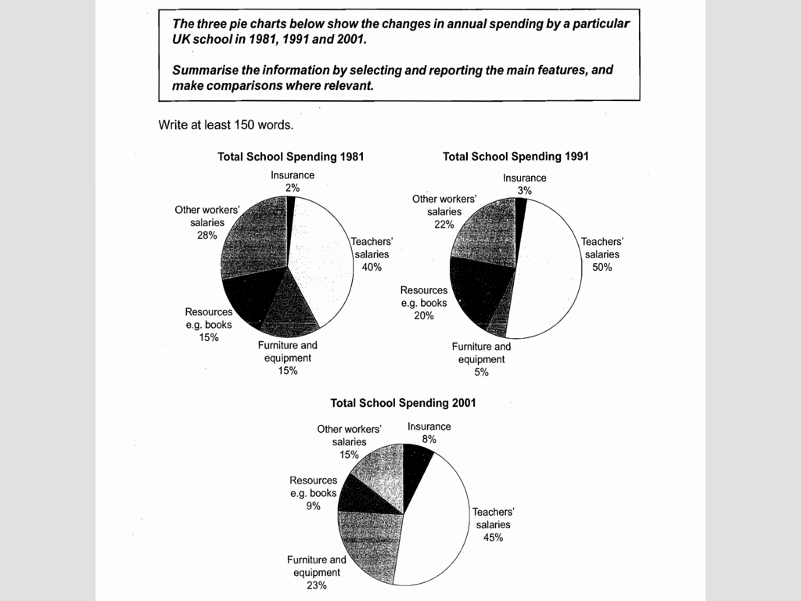

Model answer

The charts show how much a UK school **spent** on different **running costs** in three separate years: 1981, 1991, and 2001.

In all three years, **the greatest expenditure** was on staff salaries. But while other workers' salaries saw a fall from 28% in 1981 to only 15% of **spending** in 2001, the teachers' pay remained the biggest cost, **reaching** 50% of total **spending** in 1991 and **ending at** 45% in 2001.

**Expenditure** on resources such as books **had increased** to 20% **by** 1991 before decreasing to only 9% by the end of the period. In contrast, **the cost** of furniture and equipment saw an opposite trend. **This cost** decreased to only 5% of total expenditure in 1991 but rose dramatically in 2001 **when** it represented 23% of the **school budget**. Similarly, **the cost of** insurance saw a rising trend, **growing** from only 2% to 8% by 2001.

Overall, teachers' salaries constituted the largest cost to the school, and while **spending** increased dramatically for equipment and insurance, there were corresponding drops in **expenditure** on things such as books and on other workers' salaries.

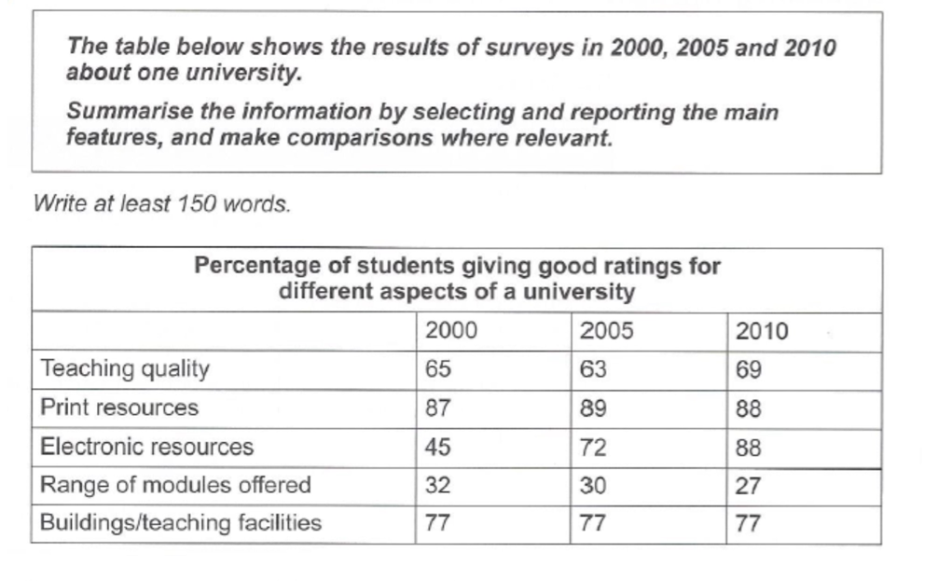

动态主语

1. The percentage of students giving good ratings for electronic resources/The percentage of students giving electronic resources a good rating

2. The percentage of students who gave good ratings for electronic resources

3. The percentage of students giving positive attitudes to/towards electronic resources

4. The percentage of students who were satisfied with(happy with/content with) electronic resources

The most noticeable change can be found in students' **approval** to electronic resources: The percentage of students giving this aspect a good rating increased sharply especially **in the first period, when** it grew from 45% to 72%, before it had increased to 88% by the end of the period. The percentage of ratings for teaching quality was generally onwards, **decreasing** to 63% in 2005 but increasing to 69% in 2000.

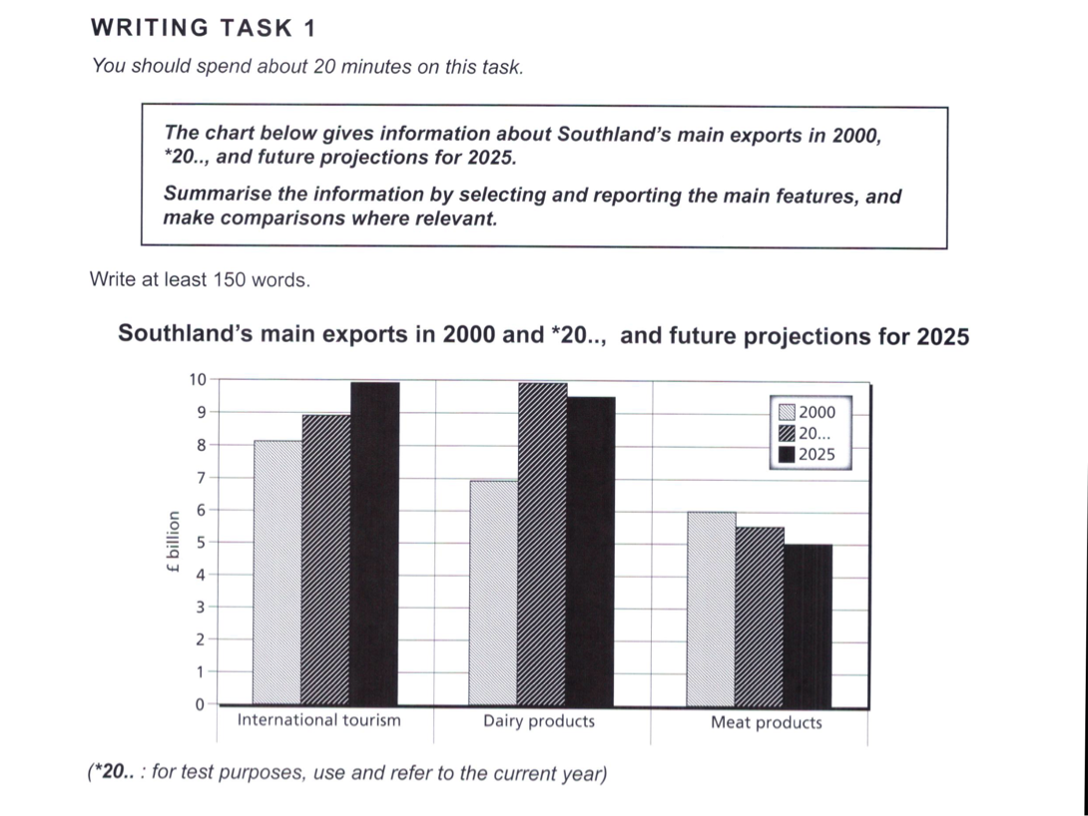

一般将来时

* will do
* Be predicted to do/be protected to do/be expected to
* It is expected that/It is predicted that
* Be likely to do

Example 4: 动态正反比

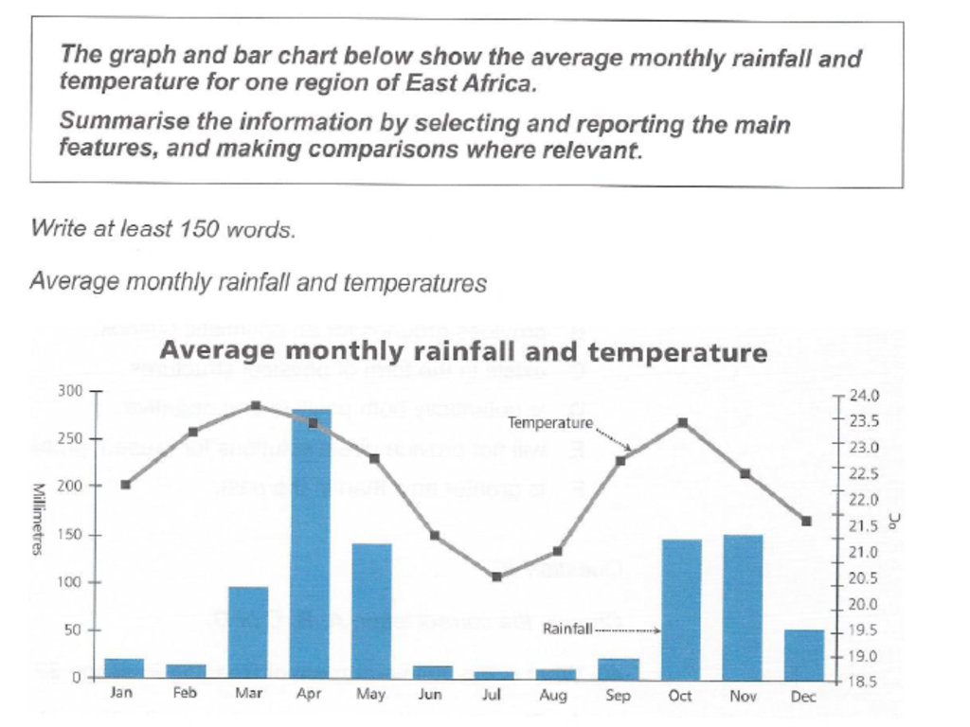

**TASK 1 写作类型3： 流程图**

**类型：工业制造（多用被动语态）; 生命&自然现象（主动语态）； 任务流程**

解题步骤

1. 看题干，了解整个流程目的

2. 确定动词（文字；图表）；确定名词

3. 确定先后关系语法现象

时态，语态，先后关系

Example 1

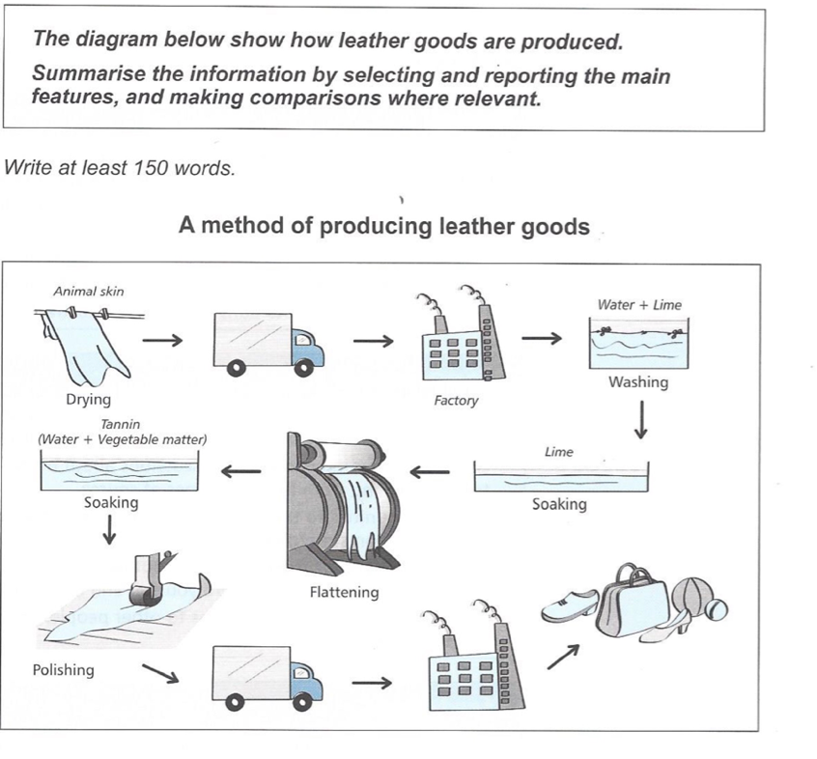

避免使用祈使句!!!!!!!

改写

1. 话题性词汇

2. 语法the process of(过程)=how=the way in which

3. 加入内容：起点／原材料

The diagram shows the process of converting animal skin into different leather goods.=The diagram shows the way in which animal skin is used to produce different leather goods.

P2: First of all , the animal skin **is hang** in the open air to **make it fully dried.** After that/Following that/In the next step(stage/phase), **the previously dried** animal skin **is delivered** by lorry to a factory. On the **arrival** of a factory, it **starts further processing stages.** The following(next) step is to **put** animal skin into a vat, where it **is washed** by the mixture of water and lime. Having been **cleaned** in that way, this skin **is transferred** into another vat to be **soaked** by only lime at this point.There comes a flattening stage, when the skin **is moved on** a rolling machine to **be pressed.** Tannin, (the substance mixed by water and vegetable matter), **is utilized to submerge** this skin again.

先后关系语法现象

1. Linking words (先后）

2. To do

3. Where/when

4. 完成时态

5. 因果linking words

6. and

2. The diagram below shows the production of electricity using a system called Ocean Thermal Energy Conversion (OTEC).

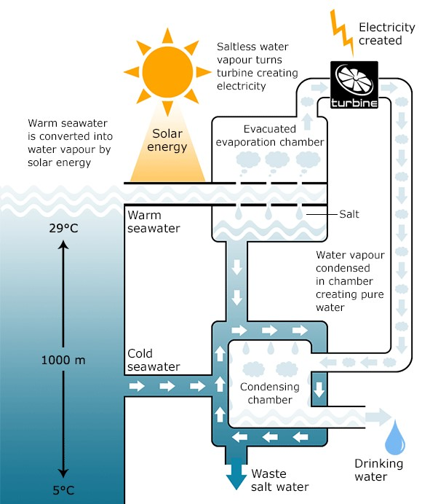

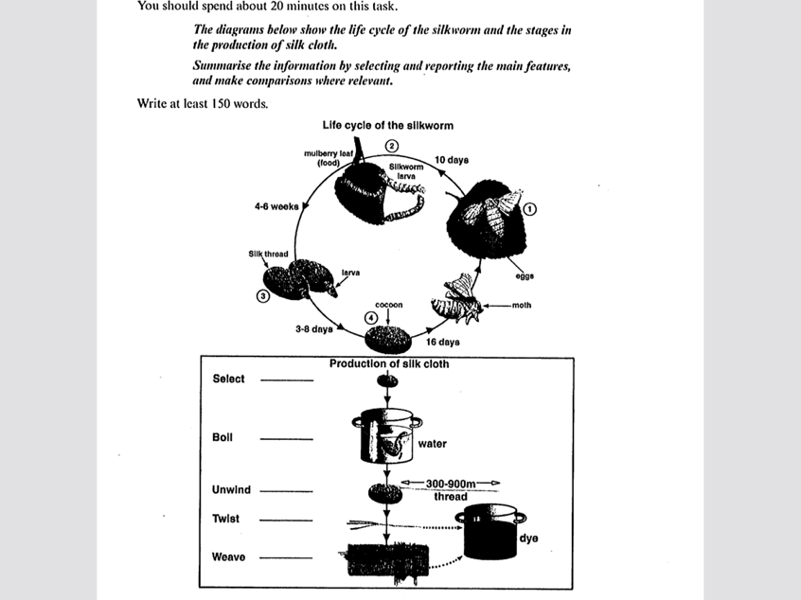

The first diagram shows that there are four main stages in the life of the silkworm. First of all, eggs **are produced by** the moth and it **takes** ten days for each egg to **become** a silkworm larva that **feeds** on mulberry leaves. This stages **lasts** for up to six weeks until the larva **produce** a cocoon of silk thread around itself. After a period of about three weeks, the adult month eventually **emerge** from these cocoons and the life cycle **begins** again.

The cocoons are the raw material **used** for the production of silk cloth. Once selected, they **are boiled** in water the threads can be **separated** in the unwinding stage. Each thread is between 300 and 900 meters long, which means they **can be twisted** together, **dyed** and then **used** to produce cloth in the weaving stage.

Overall, the diagrams show that the cocoon stage of the silkworm can be used to produce silk cloth through a very simple process. (两者关系)

**TASK 1 非数据类图表： 地图**

**类型：地理变迁， 选址题，单个地图**

**建立参照物，注意被动语态使用；积累变化词&方向词, 变化起点重要性； 倒装句等**

**写作顺序：改造前(空间方位）+改造后（变化）**

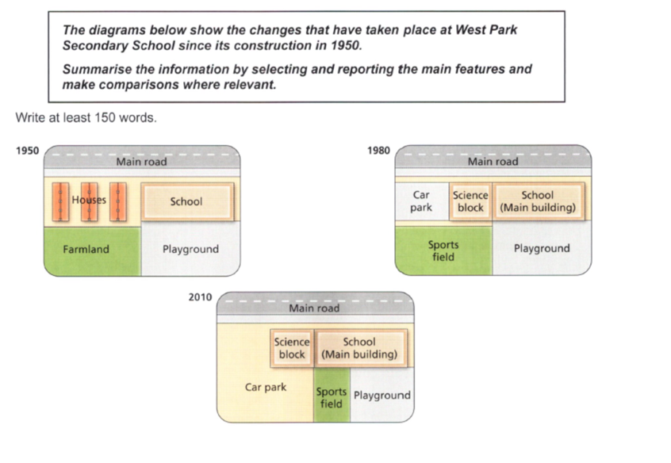

The diagrams show West Park School at three different stages in its development: 1950, 1980 and 2010.

In 1950, the school was built close to a main road and next to a number of houses. A large area behind the school was turned into a playground, while the area behind the houses was farmland.

By 1980, the houses had been demolished(be knocked down/be pulled down／be torn down) in order to make way for a small car park and an additional school building, which became the science block. In addition to the existing playground, the school also gained the farmland and converted into a sports field.

In 2010, the school building remained unchanged but the car park was extended to cover the entire sports field. As a result of this, the original(former/previous) playground was divided into two so that it provided a smaller playground and a small sports field.

During this period, the school has increased in size and a car park has been created and enlarged . The combined recreational areas, however, first expanded and were then reduced in size.

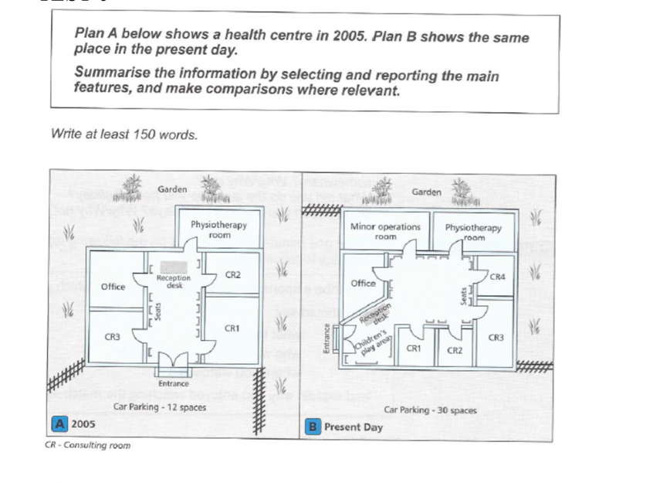

P2: In 2005, outside this health centre, there were a big garden and car parking lot which can accommodate up to 12 spaces. Inside this building, the entrance was located(was situated/sat/lay) on the bottom, **with** a reception desk in front in the middle of lobby. This centre also involved three consulting rooms, an office and a physiotherapy room.

Inside this building, the entrance was located(was situated/sat/lay) on the bottom, **in front of which** was a reception desk in the middle of lobby.

P3: But now, the previous garden **has been reduced in size** to **make room for the extension** for car parking, with more spaces available(30 spaces). The interior layout also have differed substantially, and the most striking change is on **the top-left(upper-left)** corner, where a minor operations rooms **is added to** this building next to the existing physiotherapy room. The nearby office remains almost in same size, but **is remodeled**.

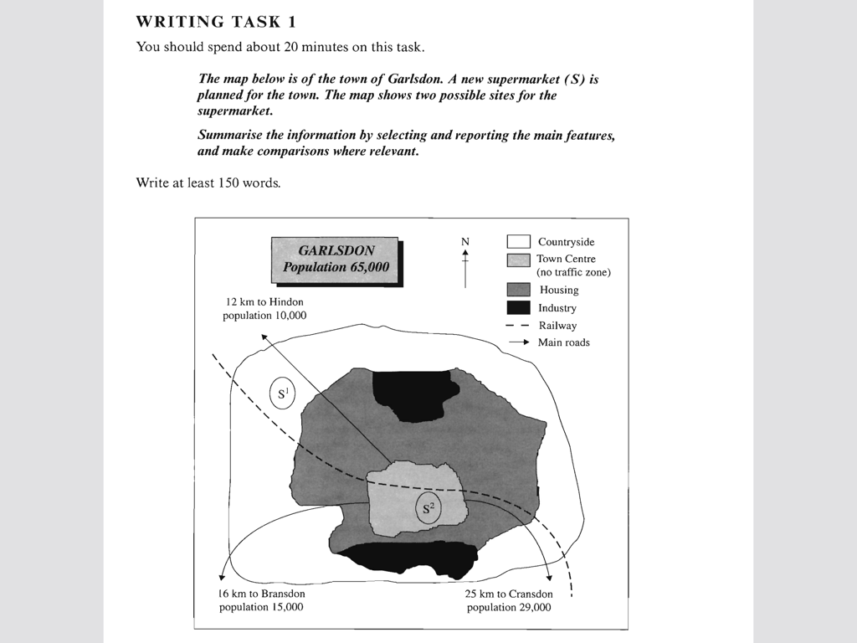

Task 2

1. Argument

* 观点类(A/D)
* 论述类(D&G)
* 利弊分析类(P/N)

1. Report
2. Mixed

开头段写作方法

* background: （大背景：key words）+小背景(改写关键词）
* Thesis statement （除了DG：论述类)

自己概括／套句

background

1. 大背景（选择性）

2. 小背景-改写话题性词汇（必须）

* 话题性词汇
* **词性**
* 近义词
* **解释**
* 正话反说
* **改变词序&增减词（改变修饰语）**
* 上下义词

**Example 1: 观点类**

Some people think that **using mobile phones and computers has a negative effect on young people's reading and writing skills**. To what extent do you agree or disagree?

The increasing popularity of **mobile phones and computers** over the past decade has prompted concern that it could **erode young people's literacy skills**, and I tend to agree with this viewpoint.

Example 2:报告类／混合类

**1. Many museums and historic sites are mainly visited by tourists rather than by local residents. What are the causes of this? What can be done for museum and historic sites to attract more local visitors?**

There exists a phenomenon that **sightseers** tend to be **more enthusiastic about museums and historically important sites** than **locals**. The aim of this essay is to discuss its causes and present some possible solutions.//In this essay I will outline some causes and possible solutions relevant to this topic.

There exists a phenomenon that **sightseers** tend to be **more enthusiastic about museums and historically important sites** than **locals**. From my point of view, the differences regarding familiarity and lifestyle are the factors leading to this phenomenon, and some feasible measures can be taken to address the problem.

Practice

**1. Some people think that the best way to improve road safety is to increase the minimum legal age for driving a car or motor-bike. To what extent do you agree or disagree?**

**2. These days, an increasing number of people in many cities know little about their neighbors and do not have a sense of community? What do you think are the causes and what solutions can you suggest?**

篇章结构： 一边倒？偏向一方？

论述类，观点类，利弊分析类，报告类

段落拓展

Topic sentence

* key words : 题目（paraphrasing&repeat)
* Key words：段落中心-general

Supporting sentences

1. Explain /Explain 1+Explain 2(why)
2. Explain +Example
3. Reason+Effect

**写作类型1： 论述类**

**Discuss both views and give your own opinion**

Example 1

***Successful sports professionals can earn a great deal more money than people in other important professions. Some people think this is fully justified while others think it is unfair. Discuss both views and give your own opinion. (Test 2, C6)***

As a result of constant media attention, **sports professionals** in my country have become stars and celebrities, and **those at the top are paid huge salaries.** Just like movie stars, they live extravagant lifestyles with huge houses and cars.

Many people find their **rewards unfair**, especially when comparing these **super salaries** with **those of top surgeons or research scientists**, or **even leading politicians** who have the responsibility of governing the country. However, **sports salaries** are not determined by considering the contribution to a society a person makes, or the level of responsibility he or she holds. Instead, they reflect the public popularity of sport in general and the level of public support that **successful stars** can generate. So the notion of **'fairness'** is not the issue.

Those who feel that **sports' salaries** are **justified** might argue that the number of professionals with real talent are very few, and the money is a recognition of the skills and dedication a person needs to be successful.／／ Competition is constant and a player is tested every time they perform in their relatively short career. ／／The pressure from the media is intense and there is little privacy out of the spotlight. So all of these factors may **justify** the **huge earnings**.

Personally, I think that the amount of **money such sports stars make** is more **justified** than the **huge earnings** of movie stars, but at the same time, it indicates that our society places more value on sport than on more essential professions and achievements.

Example 2

**In some couriers young people are encouraged to work or travel for a year between finishing high school and starting university studies. Discuss both advantages and disadvantages for young people who decide to do this. （Test2, C5）**

It is quite common these days for **young people** in many countries to **have a break from studying after graduating from high school**. The trend is not restricted to rich students who have the money to travel, but also evident among poorer students who choose to work and become economically independent for a period of time.

The reason for this trend may involve the recognition that **a young adult** who passes directly from school to university is rather restricted in terms of general knowledge and experience of the world. By contrast, those who have **spent some time earning a living or traveling to other places**, have a broader view of life and better personal resources to draw on. They tend to be more independent, which is a very important factor in academic study and research, as well as giving them an advantage in terms of coping with the challenges of student life.

However, there are certainly dangers in **taking time off** at that important age. **Young adults** may end up never returning to their studies or finding it difficult to readapt to an academic environment. They may think it is better to continue in a particular job, or to do something completely different from a university course. But overall, I think this is less likely today, when academic qualifications are essential for getting a reasonable career.

My view is that **young people** should be encouraged to broaden their horizons. That is the best way for them to get a clear perspective of what they are hoping to do with their lives and why. Students with such a perspective are usually the most effective and motivated ones. And **taking a year off** may be the best way to gain this.

Practice

***1. Some people say that children should go to school as young as possible, while others believe that children should go to school of at least 7 years old. Discuss both views and give your own option. (2018.08.25)***

***2. People have different views on how to reduce traffic congestion. Some think that governments should build more train and subway lines, while others think that building more and wider roads will reduce traffic congestion. Discuss both views and give your own opinion. (2018/07/07)***

**写作类型 2： 观点类**

**To what extent do you agree or disagree?**

**1.Many people believe that media coverage of celebrities is having a negative effect on children. To what extent do you agree or disagree with this opinion?**

P2: One of the possible **negative consequence** of the ‘**cult of celebrity**’ is the tendency to confuse **fame** and notoriety. **Celebrity scandals** are just as likely to receive publicity as celebrity achievements. Indeed, some **famous people** have received more attention for their misuse of drugs and alcohol than their success on the stage or in sports. Children who crave attention may come to see misbehavior as normal.

P3: The emphasis on individuals **in the public eye** may also be at the expense of **serious news coverage.** Next to the superficial excitement of **celebrity gossip,** news about serious events and issues that have a more profound effect on people’s lives may seem uninteresting(indifferent). Children may be forming a very distorted picture of how the world works.

P4: **The negative influence of celebrities on children** can also be seen in children’s career aspirations. These days, **young people** are much more likely to see themselves as potential sports people or entertainers. **The prevalence of these figures in the mass media** may convey the impression that such positions are plentiful. Children may be developing unrealistic expectations that too will become rich and famous.

In summary, the ‘cult of celebrity’ may be affecting children in a number of undesirable ways.// It is important that children should be taught to critically evaluate what they see in the media so that they can form a more realistic view of society, acceptable behavior and indeed themselves.

***3. Some people think that social networking sites have a huge negative impact on both individuals and society. To what extent do you agree or disagree?(2017.12.16)***

***2. Some people think that the best way to improve road safety is to increase the minimum legal age for driving a car or motor-bike. To what extent do you agree or disagree?***

P2: It is claimed that **increasing the minimum age for legal car driving** can be effective in improving **the safety of road users** for the reason that the older of a driver, the less likely he or she is to be involved in accident. But in fact **simply limiting driving age** is no way to ensure safe driving, and other more important factors such as traffic offense, challenging weather conditions and poor driving skills, often increase the risks on road. Effectiveness

***4. It is shown that many criminals have a low level of education. Some people argue that the best way to reduce crime is to educate criminals in prison to help them find jobs when they leave prison. Do you agree or disagree? (2018.11.03)***

**写作类型 3： 利弊分析类**

***1. In some cities, the governments have tried to reduce traffic. For instance, they imposed a congestion tax during rush hours. Do you think this development is positive or negative?(2016/01/30)***

P2: The benefits of **putting a congestion levy** can be manifest(apparent/evident), and it would be no exaggeration to say that **this** can **reduce traffic volumes** in a charged zone as public modes of transport, off-peak traveling; ride sharing can become more popular substitutes for cars, especially for those with limited budgets.

***2. In some countries, more and more adults choose to continue to live with their parents after they graduate and have found jobs. Do the advantages of this trend outweigh its disadvantages?***

*P2：* Lives would be made miserably if **grown-ups return home with parents.** The quality of life is often measured by freedom, pleasure and autonomy, but hardly can these needs be fulfilled if there is a **multi-generational living** condition. This is not restricted to young adults, but also to parents.....

**TASK2写作类型4：报告类**

**1. As most people spend a major part of their adult life at work, job satisfaction is an important element of individual wellbeing. What factors contribute to job satisfaction? How realistic is the expectation of job satisfaction for all workers? (Test 3, C7）**

Nowadays many adults have full-time jobs and the proportion of their lives spent doing such jobs is very high. So feeling about one's job must reflect how an individual feels about his or her life as whole, and because of this, **job satisfaction** is indeed very important for the wellbeing of that person.

Employees get job satisfaction in a number of ways. Firstly, a person needs to feel that they are doing valued and valuable work, so positive feedback from superiors is very important in this respect. A sense of fulfillment is also encouraged if a worker feels the job is worth doing because it contributes to the society or the economy as a whole. Secondly, when someone feels they are improving or developing their skills through training opportunities, for example, then there is a sense of progression and purpose that rewards a worker. The sense of belonging to a team or a working community also contributes to **job satisfaction** because colleagues help each other to enjoy their working lives. Satisfaction is also increased by a sense of responsibility for and loyalty to a team.

Of course not everyone enjoys their work. Hard economic realities mean that many people have little choice in the kind of job they can get. In some cases an employee is working in a job that suits neither their skills nor their personality. Some jobs are repetitive and boring, and labor relations may be poor and lead to resentment and insecurity rather than to **job satisfaction**.

However, even though it is unlikely that all workers **do feel happy** in their work, I think it is not unrealistic to promote more job satisfaction in any job. If these factors identified above are implemented, then any job can be improved and more workers can feel **greater degrees of job satisfaction**.

**2. In some counties around the world men and women are having babies late in life. What are the reasons? Do the advantages outweigh the disadvantages? (2017/04/08)**

P2: The primary reason why couples **delay the age of delivering a baby** is associated with economic factors. It is far more costly to raise children and live in general nowadays, and hopefully by waiting to be financially stable would it put on agenda for young people. Also...

In addition...

3. **These days, people in many cities know little about neighbors and do not have a sense of community?**

**What do you think are the causes and what solutions can you suggest(2018/07/19)**